# ValueError Bug

Describe the bug

When entering the year, if a string is entered the program exits with a -1 code and a valueErrorr

Program

Full_retirement_age_calculator_app.py

Component

Full_retirement_age_calculator_app.py

Error Type

ValueError

Severity

Fatal

Priority

TBD

## State

Open/Accepted/Working/Test/Rejected/Deferred/Closed

To Reproduce

Steps to reproduce the behavior:

1. Run program
2. Enter a string when prompted for year born
3. .
4. .

Expected behavior

The program should tell the use that they have entered an invalid input. In this case it would be a valueError for the year born. The program may want to advise the user to enter an integer within a given range for a valid input.

Screenshots

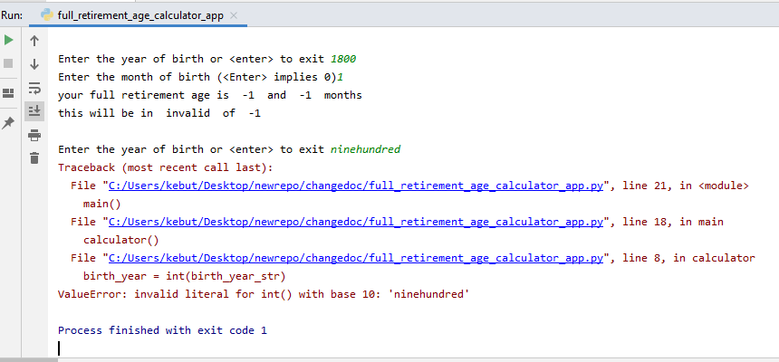

Desktop

Please complete the following information:

* OS: Windows 10
* Browser N/A
* Version [e.g. 22]

Additional context

N/A

Assigned

Unassigned